Preliminary Manual for

Community based monitoring of
natural resource use and forest quality
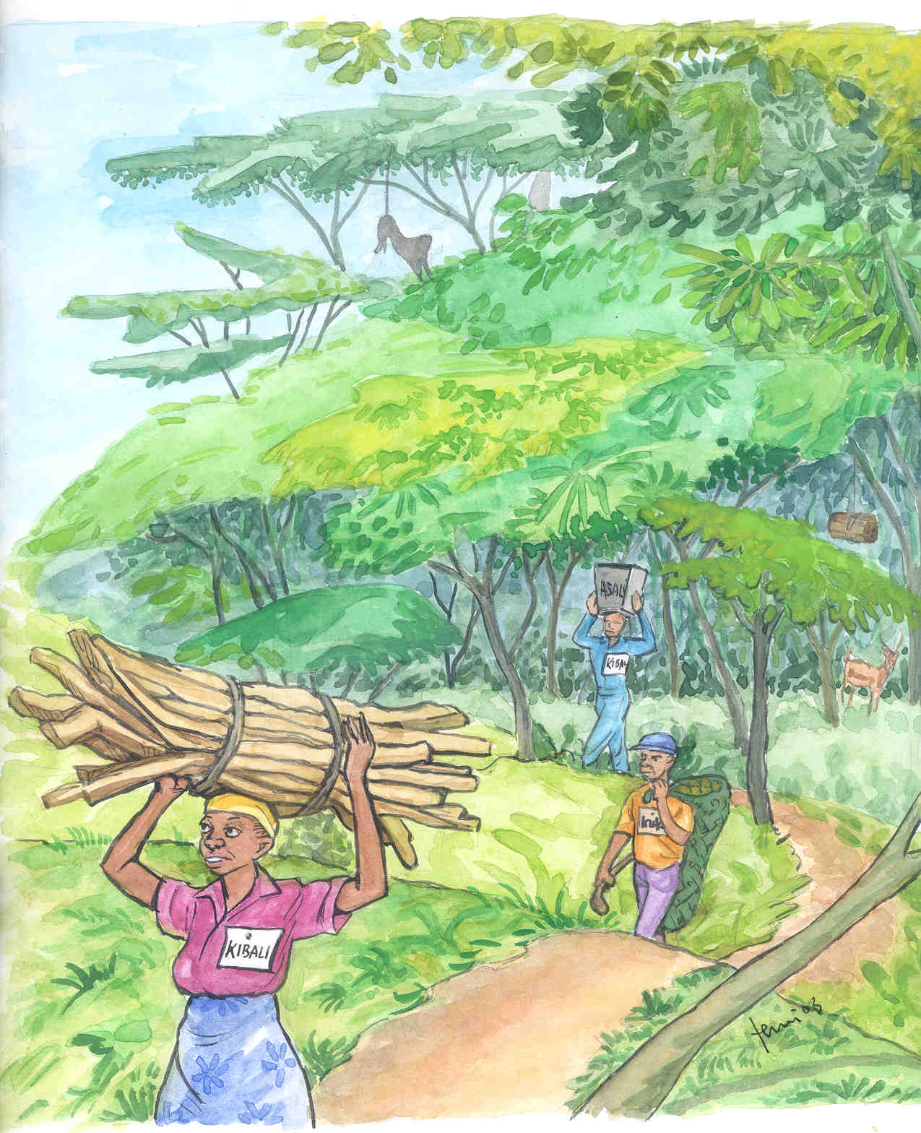

District Lands, Natural Resources and Environment Office, Iringa

CREDITS

This document has been prepared by Iringa District Lands, Natural Resources and Environment Office supported by the MEMA Projects. The MEMA Projects are funded by DANIDA.

The Village Natural Resources Committees and Patrol Guards in Kidabaga and Nyang’oro villages have been involved in selecting and developing the methods presented in this manual. In Kidabaga: L. Masaki, VNRC Chairman; Bernard Msungu, VNRC Secretary and Interview Chairman; Anna Nyangwa, VNRC Treasurer; Victory Nwunda, VNRC Member; Peter Mgelwa, VRNC Member; Odeta Kiwoti, VNRC Member; Frances Kiwola, VNRC Member; Batista Chahe, Patrol Guard; Veronica Kihakwi, Patrol Guard; and Lactali Mmehwa, Patrol Guard. In Nyang’oro: Yohanis Lugala, VNRC Chairman; Fanuely Hongole, VNRC Secretary; Gelady Mvili, VNRC Interview Chairman; Daud Holgole, VNRC Member and Patrol Guard; Paskar Mvili, VNRC Member; Hamis Mbugi, VNRC Member; Yolanda Kibuga, VNRC Member; Batrumeo Sanga, Patrol Guard; Augustino Mwelasi, Patrol Guard; Jonn Mpagama, Patrol Guard; Dominicus Lubava, Teacher; Dani Kalinga, Patrol Commander; Bathromeo Sanga, Patrol Guard; Damas Kimemle, Game Survey Assistant; and Elenest Makela, Game Survey Assistant.

The Village Natural Resources Committees and Patrol Guards in the 23 MEMA Project villages have tested full implementation through November 2002 – March 2003 and have commented on data forms and methods. These villages are Chamdindi, Ifuwa, Ikengeza, Ilamba, Isele, Itagutwa, Izazi, Lulanzi, Lusinga, Kidabaga, Kinywang’anga, Kitapilimwa, Kiwele, Magome, Makatapora, Makuka, Mangawe, Mfyome, Migoli, Mkulula, Nyang’oro, Udekwa and Usolanga.

Contributions through discussions with and advice to villagers in one or more village: Luvanga Division Game Officer; Didas Lyamuya, Divisional Catchment Forest Officer; Henry Magova, Forest Assistant; Majid Mhina, MGM Consultant; Hamis Malinga, Divisional Catchment Forest Officer; Florence Nikata, Divisional Forest Officer; Charles Madaha, Divisional Catchment Forest Officer; Michael K. Poulsen, NORDECO consultant; and Elmer Topp-Jørgensen, NORDECO consultant.

Contributions through discussions in Iringa, comments and suggestions: S. Fute, Ward Forest Officer; Louis A. Hansen, Biologist; J. N. Hanti, District Lands, Natural Resources and Environment Officer; J.J. Isaack, District Fisheries Officer; J. Isango, TAFORI Researcher; T. Kahatano, District Bee-keeping Officer; K. Kyungu, GIS Officer; I. Kimaro, District Game Officer, Henrik Lerdorf, TA MEMA; Majid Mhina, MGM Consultant; I.S. Massam, Regional Forest Advisor; J.F. Massao, District Catchment Forest Officer; David Moyer, WCS Representative; Dr. Martin Walsh, MBOMIPA Representative; W. Mshangama, InfoBridge Consultants Limited; O. Mtavilalo, Forest Revenue Officer; M. Mwagala, Game Revenue Officer; Michael K. Poulsen, NORDECO consultant; Bill Stanley, FMNH Chicago; and Elmer Topp-Jørgensen, NORDECO consultant.

Text and Layout: Majid Mhina, MGM Consultant; Elmer Topp-Jørgensen, Biodiversity Specialist, NORDECO; and Michael K. Poulsen, Participatory Biodiversity Monitoring Specialist, NORDECO.

Illustrations: Temu Arts & Graphics, Dar es Salaam and Mdenya Arts, Iringa.

© Iringa District Lands, Natural Resources and Environment Office, 2003.

Contacts:

District Lands, Natural Resources and Environment Office, Iringa
P. O. Box 773
Iringa
Tanzania

DLNRO.IDC@twiga.com

NORDECO
Skindergade 23, 3.
DK-1159 Copenhagen K
Denmark

E-mail: nordeco@nordeco.dk
www.nordeco.dk

Preliminary manual for

Community Based Monitoring of
Natural Resource Use and Forest Quality

Contents

Page
1. Introduction 4
2. Why monitoring is important 5
3. Data storage 6
4. Patrolling − Field observations of forest resource use, disturbances and selected wildlife 8
5. Perception Interviews − Villagers perception of status and trend of natural resources 10
6. Monthly report from Village Natural Resource Committee 12
7. What should be discussed at Village Natural resource Committee meetings 14
8. Possible Management Plan adjustments related to changes in resource availability 16
9. Village Natural Resource Committee activities and decisions that should be presented at Village General Assemblies 18
Annex 1. Patrol Form 20
Annex 2. Perception Interview Form 22
Annex 3. Report from Village Natural Resource Committee 24

- Introduction
This manual explain how villages can safeguard their forest and its biodiversity, and how they can ensure that natural resource extraction does not exceed sustainable levels.

The forests are managed through Joint Forest Management Agreements that give rights and possibilities to the villages situated around the natural forests. The forests are now managed jointly between the villages and district authorities. In the village, it is the Village Council, through the elected Village Natural Resource Committee that manages the forest on behalf of the villagers.

The Joint Forest Management Agreements give rights as well as responsibilities to the villages:
- Villagers can extract natural resources from the forest as long as the use is sustainable.
- The Village Council together with the Village Natural Resource Committee is responsible for ensuring that resource extraction does not exceed sustainable levels.
- The Village Natural Resource Committee must monitor the resource use and the state of the forest to ensure that resources are not depleted and that the forest is not disappearing.
- The Village Council and Village Natural Resource Committee can use by-laws with rules for permits, fees and fines to control the level of resource use.

District authorities must support and guide the villagers to become good forest managers. They will meet regularly with Village Natural Resource Committees to discuss their work. Management changes suggested by the villages will normally be accepted if they are in line with national laws and the aims of the Management Plan. District authorities must always intervene if the forest is being degraded or its resources depleted.

- Why monitoring is important

Joint Forest Management Plans allow villagers to extract natural resources. This can reduce poverty and improve livelihoods among the villagers. However, the resources must be used wisely, meaning that extraction should not exceed sustainable levels.

Information on the status of forest resources and quality must be gathered regularly so that the level of resource use can be changed according to observed trends. It is necessary to react to this monitoring information by changing relevant rules and regulations in the management plan if some resources are becoming scarce or forest quality is threatened.

Continued monitoring will tell the Village Natural Resource Committee if the adjustments to the Management Plan have increased resource availability or forest quality, or if further adjustment is needed. Continued monitoring of the forest and its resources will ensure that resources, services and biodiversity will persist in the forest, also for future generations.
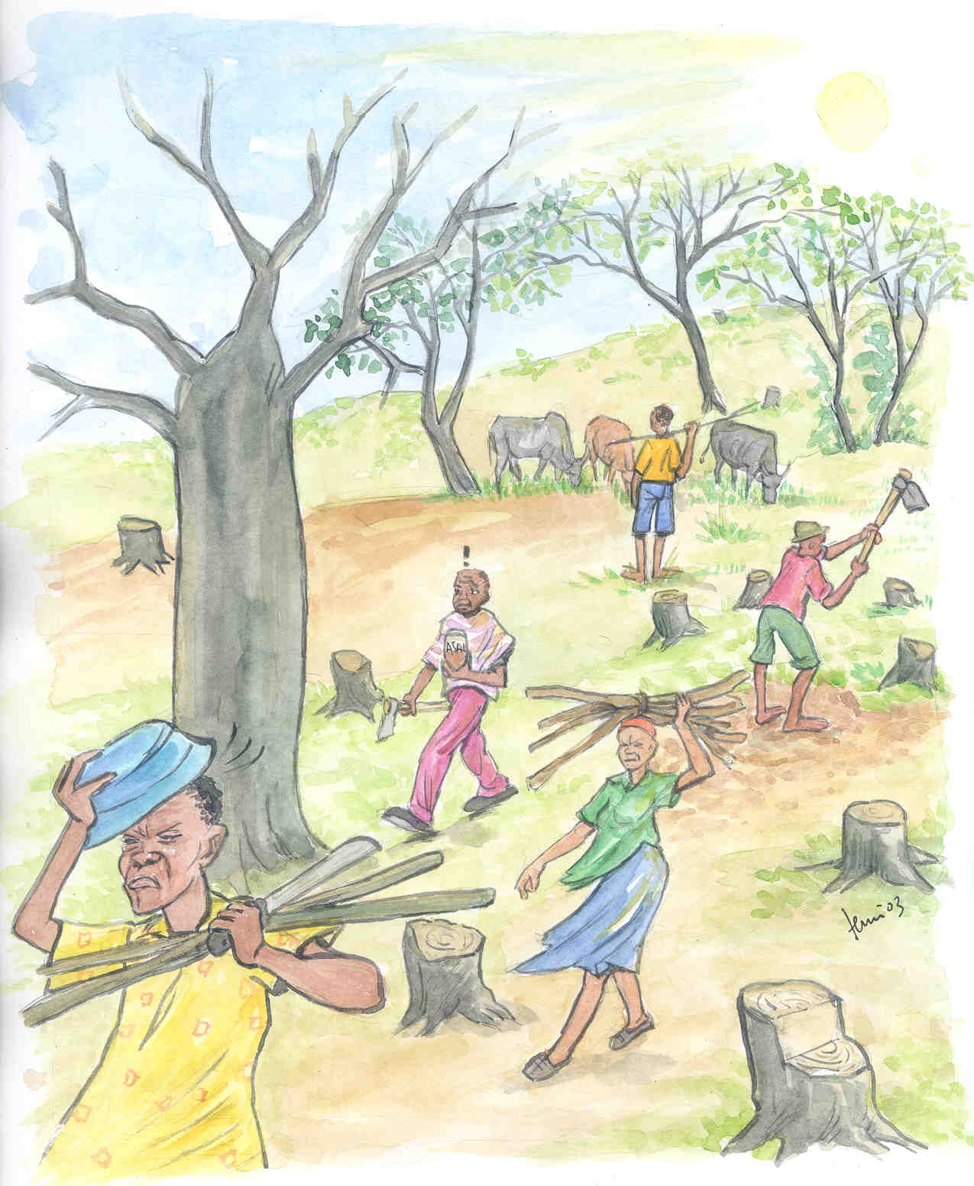

Two methods have been developed to collect information on the status of forest resources and forest quality: Patrolling in the forest and Perception Interviews with villagers.

Patrolling is a method whereby Patrol Guards record disturbances, resource extraction and selected wildlife during regular walks in the forest.

Perception Interviews is a method where information is collected on what resources are important to the villagers, the status and trend of important resources and which wildlife species are perceived as a problem to their livelihoods. Both these methods will be described in details later in this manual.

A summary report is produced every month. This Report from Village Natural Resource Committee includes a:
- Summary of Village Natural Resource Committee activities (meetings, Village General Assemblies and training/workshops).
- Summary of permits, revenue, fines and expenditure.
- Summary of patrol observations.
- Summary of Perception Interviews with villagers.
- Data storage

Comparing old and new information is central to monitoring. Data storage is therefore very important. There must be no doubt as to what information is to be kept, where it should be kept and who is responsible for this.

Data collected, stored and used by the Village Natural Resource Committee

Records of Village Natural Resource Activities: Village Natural Resource Committee meetings, Village General Assemblies (if on natural resource use) and training/workshops.
- Person responsible: Village Natural Resource Committee Secretary.
- Records kept in Secretary’s book.

Records of permits, revenue, fines and expenditure.
- Person responsible: Village Natural Resource Committee Treasurer.
- Records kept in Treasurer’s book.

Records during patrols.
- Person responsible: Patrol Commander.
- One form filled in for every patrol. Forms kept in a file in the Village Natural Resource Committee Office.

Records of interviews of villager’s perception of resource status and trends.
- Person responsible: Village Natural Resource Committee Interview Chairperson.
- One form filled in for every Interview. Forms kept in a file in the Village Natural Resource Committee Office.

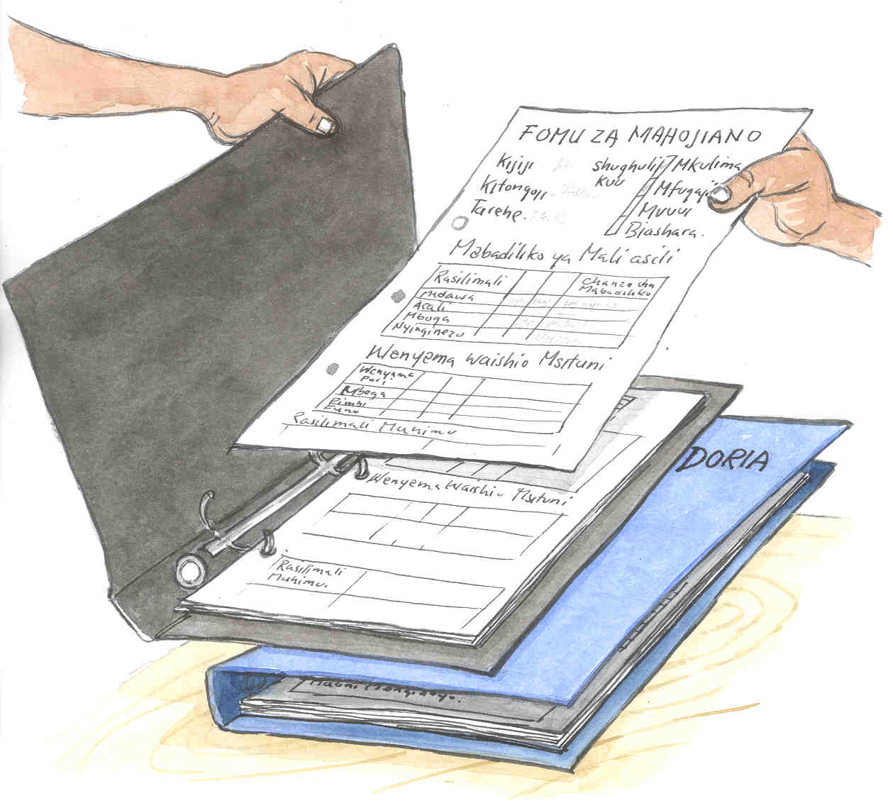

Data stored and used by District Land, Natural Resource and Environment Office, Divisional Secretary, Ward Executive Officer and Village Natural Resource Committee

Monthly Report From Village Natural Resource Committee including:

      - Summary of Village Natural Resource Committee activities (meetings, Village General Assemblies and training/workshops).

      - Summary of permits, revenue, fines and expenditure.

      - Summary of patrol observations.

      - Summary of Perception Interviews with villagers.

  - Person responsible: Village Natural Resource Committee Secretary.

  - Form kept in a file in the Village Natural Resource Committee Office.

  - Copies of the form are delivered to District Land, Natural Resource and Environment Office, Divisional Secretary and Ward Executive Officer.

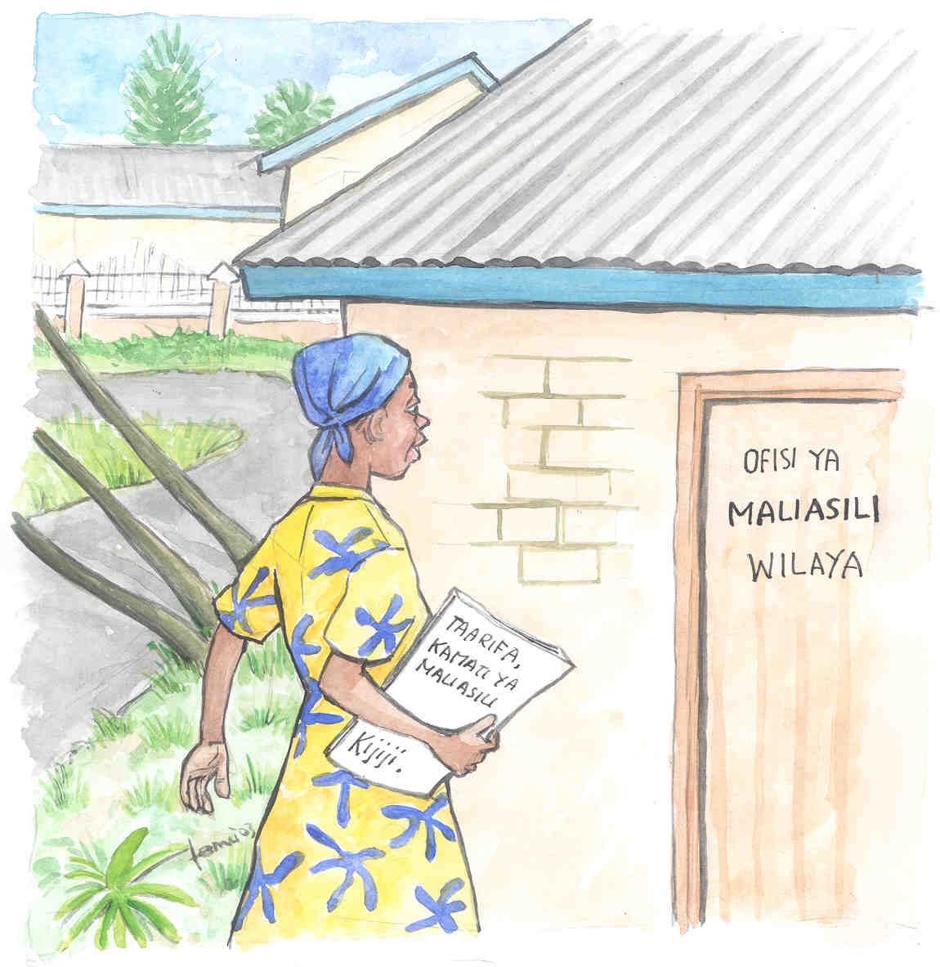

- Patrolling − Field observations of forest resource use, disturbances and selected wildlife

Method number one is Patrolling
Patrolling in the forest is an important part of the monitoring carried out by the Village Natural Resource Committee. It is a way of collecting information about the magnitude and effects of the present level of resource use and disturbance.

By the means of regular walks in the forest, the Patrol Guards record the state of the forest through observations of resource uses, disturbances and selected wildlife. Through these records, the Village Natural Resource Committee will receive reliable information on the status of the forest and its resources. This will enable the Village Natural Resource Committee to make the right management decisions targeting observed threats to the forest and its resources.

Combined with other monitoring methods, this allows the Village Natural Resource Committee to adjust the Management Plan (e.g. levels of resource use) to ensure that resources are used sustainably.
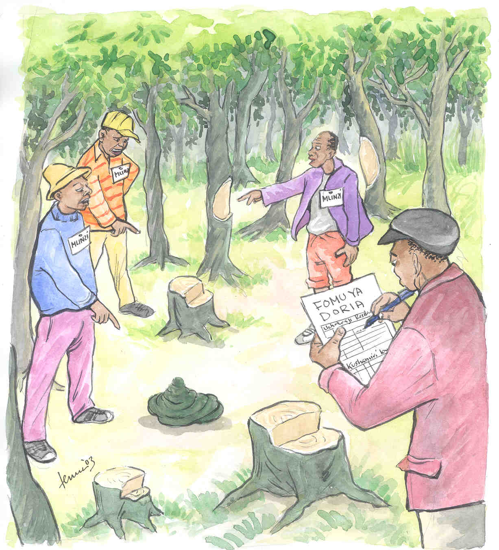

The patrol form (Annex 1) contain two main sections:

- Observations of disturbances and resource extractions that may be a threat to the forest.

- Observations of selected wildlife, which:
- Depend on good forest quality, or
- Are vulnerable to forest disturbance, or
- Are endemic species found only in Tanzania, or
- May have significant impact on the livelihoods of the villagers.

Who carries out the patrols?
- Patrol Commander and Patrol Guards carry out patrols in groups of 2-4 persons.
- The Patrol Commander will make sure that patrols are carried out by Patrol Guards according to an agreed timetable (see “When to patrol” below).
- One patrol form is used for every patrol. The Patrol Commander is responsible for patrol forms reaching the Village Natural Resource Committee Secretary who will store the forms in a file.

When to patrol: Once per week, or any time the Patrol Commander/ Village Natural Resource Committee may find it necessary (e.g. when disturbance levels increase).

Where to patrol: Patrols should be carried out in the natural forest. The Patrol Commander and Patrol Guards select an area or route where to patrol. This area or route should be changed for every patrol in order to cover different areas of the forest.

How are patrols financed? Patrol Guards should be compensated for their time spent on patrols. The Village Council must discuss how they are compensated.

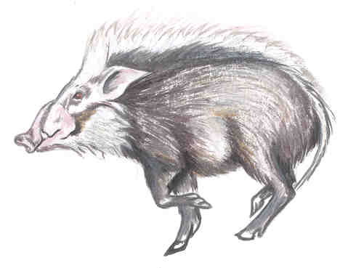

- Perception Interviews − Villagers’ perceptions of natural resource status and trends

Method number two is Perception Interviews
Perception Interviews with villagers is a way for the Village Natural Resource Committee to collect information on how the villagers perceive the availability of and trends in forest resources. One Perception Interview form is used for every interview.

The interview form (Annex 2) contains four main sections:
- Perception of forest resource status and trends.
- Will inform Village Natural Resource Committee about perceived status of and trends in selected resources from the natural forest.
- Resources considered most important to the villagers.
- Will tell Village Natural Resource Committee which resources from the natural forest that are most important to villagers.
- Perception of status of and trends in wildlife that pose a threat to crops or livestock.
- Will inform Village Natural Resource Committee of wildlife, that is of concern to the livelihoods of the villagers.
- The villager’s knowledge of Village Natural Resource Committee activities.
- Will inform the Village Natural Resource Committee as to whether villagers are aware of the work and responsibilities of the Village Natural Resource Committees or whether more awareness raising is necessary in the village.
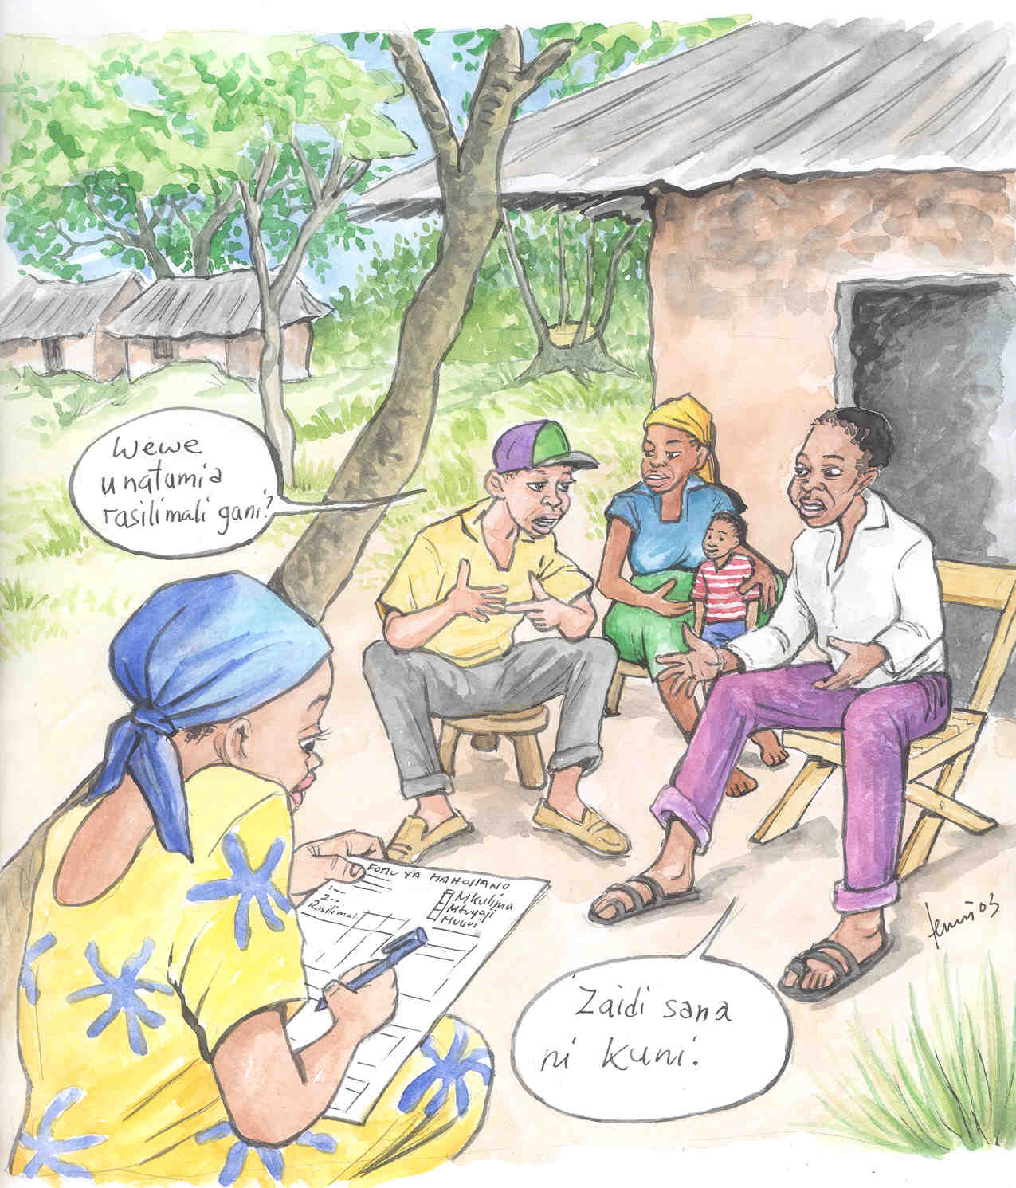

Who carries out the interviews?
Village Natural Resource Committee Interview Chairperson together with a Village Natural Resource Committee member from the sub-village where the interview takes place.
The Interview Chairperson is responsible for ensuring that all forms reach the Village Natural Resource Committee Secretary, who will store the form in a file.

How often should Perception Interviews be carried out?
At least 5 interviews per month.

Who should be interviewed?
Interviews should be carried out with households in all sub-villages. The Village Natural Resource Committee should establish a rotation system that ensures interviews are carried out in all sub-villages within the same year.

  - Households should be selected that represent the different occupations undertaken by villagers in the village (farmers, pastoralists, fishermen, natural resource business, etc.).

  - All available members of the household should take part in the interview.

The Village Natural Resource Committee members should visit the interviewees at their homes. The same household should NOT be interviewed twice within the same year.

Important: Before starting the interview, explain thoroughly the purpose of the interview. Explain that the Village Natural Resource Committee manages the forest on behalf of the villagers and that you are seeking their help to obtain information about the status of and trends in forest resources. This will help the Village Natural Resource Committee to adjust the Management Plans to ensure sustainable use of natural resources. If this is not explained thoroughly, villagers may be afraid to reveal their knowledge of forest resources.

- Monthly report from Village Natural Resource Committee

The monthly report is designed to give the Village Natural Resource Committee members an overview of the all monitoring related activities.

The following information is summarised on the monthly report form (Annex 3):

From Village Natural Resource Committee Secretary’s books:

Details from meetings, Village General Assemblies and Training exercises. Include dates, number of women and men, and main topics discussed.

From Village Natural Resource Committee Treasurers book:
- Number of issued permits and revenue from each resource, revenue from fines and expenses related to Village Natural Resource Committee activities.

From Patrol Form:
- Summary of information from all Patrol Forms. Take all forms from relevant month and summarise results. This section will show the Village Natural Resource Committee which resource uses and disturbances pose a threat to their forest, and the status of selected wildlife.

From Perception Interview Form:
- Summary of information collected during all interviews. Take all forms from relevant month and summarise results. This section will show the Village Natural Resource Committee how the villagers perceive the status of and trends in important natural resources coming from the forest.

The form also has space for Village Natural Resource Committee comments regarding the level and effect of forest resource use (including comments on rules and regulations concerning permits and natural resource revenue).

When should the form be filled in?
The Village Natural Resource Committee should meet once per month to fill in the form.
All members should be aware of the activities undertaken by the Village Natural Resource Committee. It is therefore important that both Village Natural Resource Committee members and Patrol Guards take part in the meeting.

Who should make sure that the report from the Village Natural Resource Committee is produced every month?
- The Village Natural Resource Committee Secretary must invite Village Natural Resource Committee members and Patrol Guards to the monthly meeting.
- Before the meeting, the Secretary should make sure that all Patrolling and Perception Interview forms for the particular month has been received.
- At the meeting, the monthly report form must be filled in and discussed by the Village Natural Resource Committee members and Patrol Guards. The form should be stored in a file in the Village Natural Resource Committee Office.

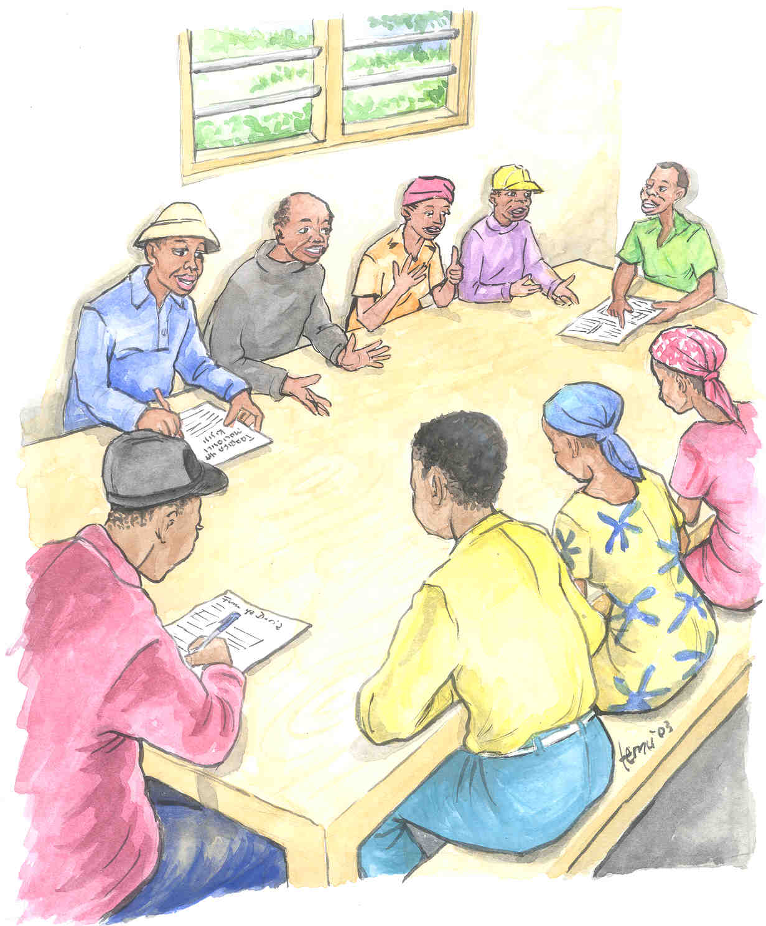

Who should the monthly report be distributed to?
Copies of the monthly summary report should be distributed to:
- District Land, Natural Resources and Environment Office.
- Divisional Secretary.
- Ward Executive Officer.

Who is responsible for distributing the monthly report?
The Village Natural Resource Committee Chairman is responsible for ensuring that copies of the monthly report reach the above mentioned Office/personnel.

This form should be brought to Forest Co-ordination Committee meetings, where activities and findings should be discussed.

- What should be discussed at Village Natural resource Committee meetings

The Village Natural Resource Committee should always seek to be aware of the status of and trends in forest resources, and the present threats to the forest.

The Village Natural Resource Committee should discuss the levels of resource use and disturbance, and they should discuss the status of and trends in forest resources and wildlife. This information is summarised on the monthly report from the Village Natural Resource Committee. This form should therefore be used as a basis for discussions.
Discussion of these issues will enable Village Natural Resource Committee members to make the best possible adjustments of the management plans to ensure sustainable use of natural resources and protection of biodiversity.

Issues that need special attention

If illegal activities and disturbances are encountered in the forest, then discuss the following questions.

1. | What is the reason for the illegal activities/ disturbance?
2. | What can be done to stop the illegal activities/ disturbance?
3. | What actions should be taken?  Agree on actions to take in order to stop illegal activities/ disturbance in the forest:  - Inform/ educate villagers at a Village General Assembly  - Increase number of patrols  - Increase fine
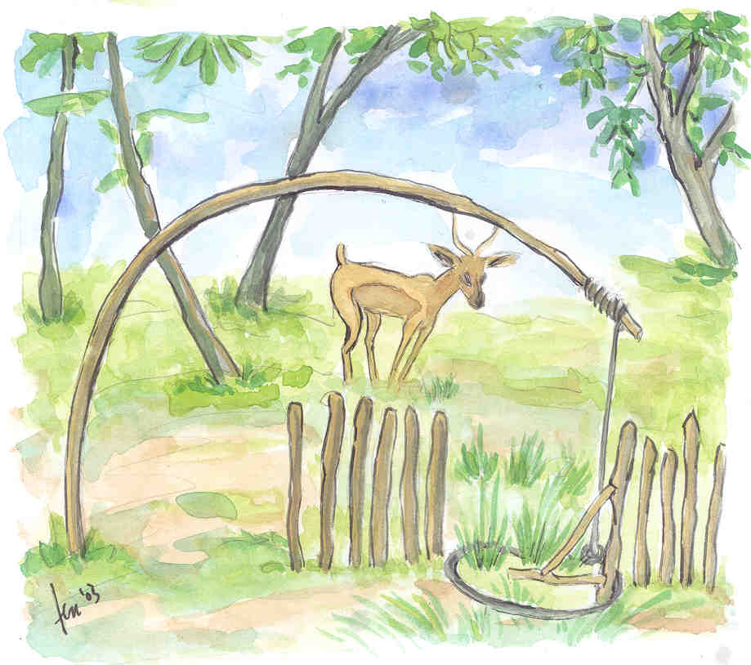

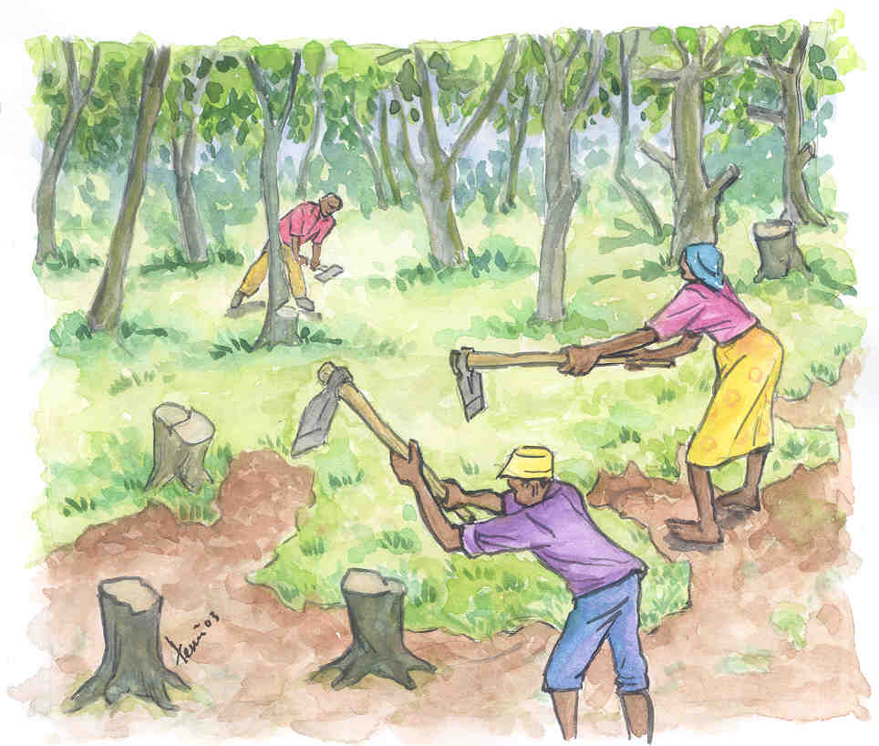

Resources (including wildlife) that have experienced a negative trend, and resources that are perceived as scarce.

1. | Is the change real? | Is it a general perception of most Village Natural Resource Committee members (and villagers) that the observed trend is negative?
2. | What is the cause? | If it is agreed that the trend is negative, then discuss what is causing this negative trend.
3. | How should we respond? | Discuss what can be done to stop the decrease in the resource (the negative trend) and if necessary discuss what can be done to increase the availability of the resource.
4. | What actions should be taken? | Agree on what actions to take in order to stop the decrease of the resource, and how to increase its availability if this is perceived necessary. (See possible management responses, section 8).

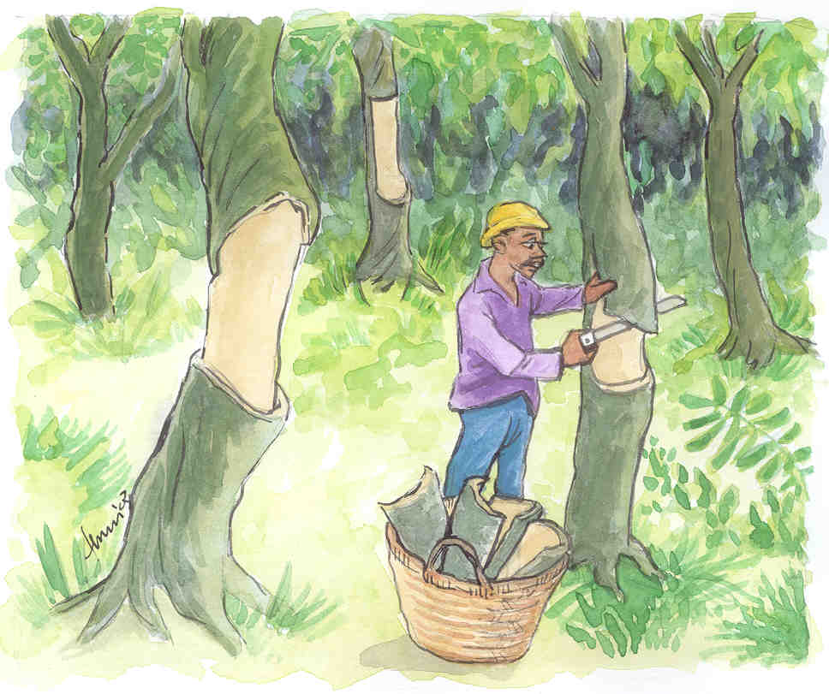
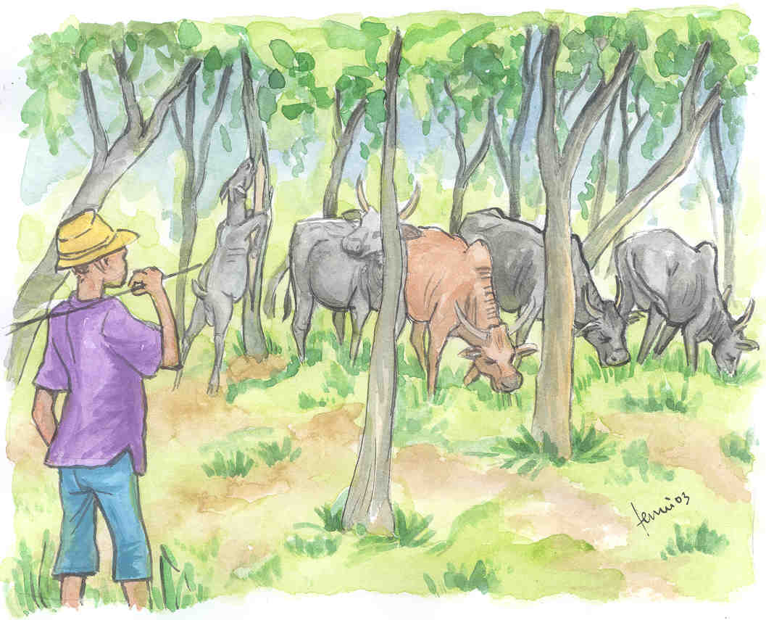

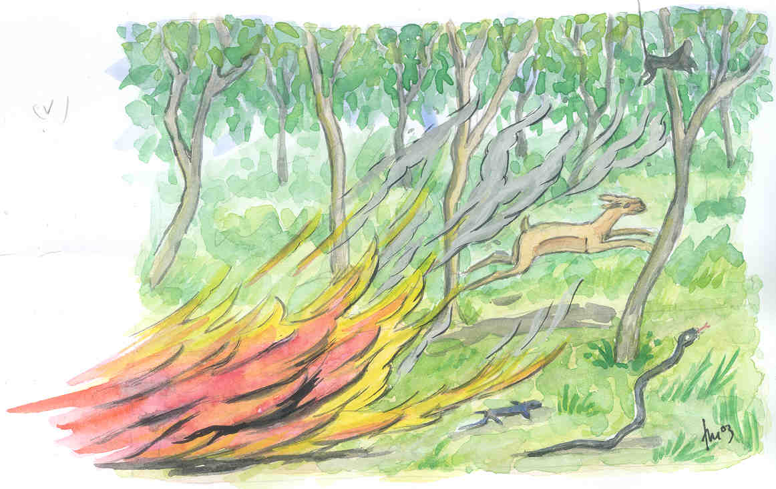
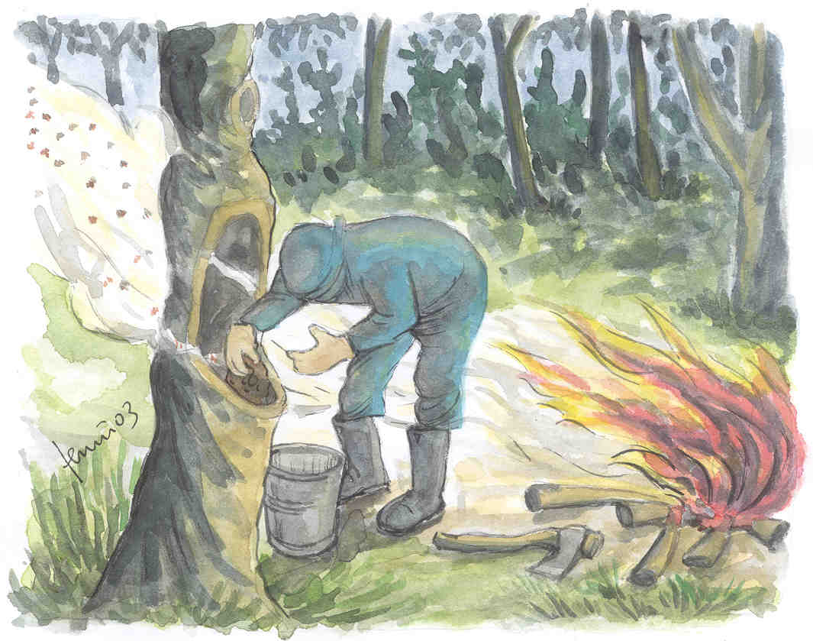
- Possible Management Plan adjustments related to changes in resource availability

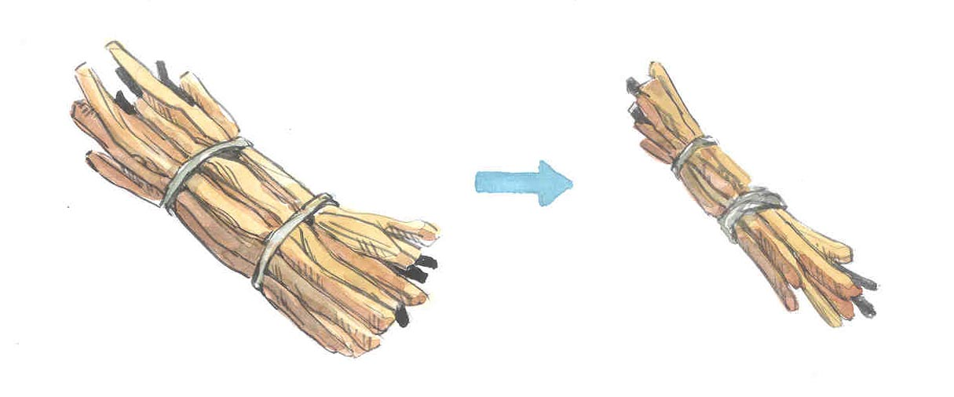
If villagers harvest too much of a resource, the resource may decrease in availability or become scarce. It is therefore important that the Village Natural Resource Committee discuss such resources, because it may require adjustments of the Management Plan to increase the availability of these particular resources.

Resources that are decreasing
If a resource is decreasing you will have to act fast and change your management regulations to ensure the specific resource is not depleted. What can be done to stop the decrease should be discussed.

The management response could be:
- To decrease (or stop) the harvesting of the specific resource.
- To reduce the number of licenses issued for the specific resource.
- To start using licenses for the specific resource, if it was free to collect before the decline was noted.
- To increase the price for a license of the specific resource in order to make it less favourable to extract.

Resources that are scarce
If an important resource is scarce, it may be relevant to discuss how this specific resource can be increased through management initiatives.

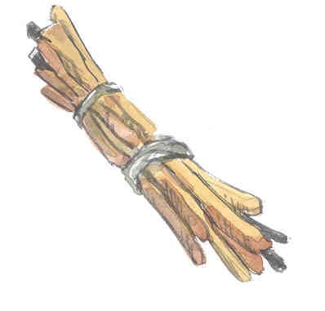
The management response could be:
- To seek advice from the Forest Co-ordination Committee or Forest Extension Officer (or other District Natural Resource Office staff) in order to increase availability of the specific resource.
- To decrease (or stop) the harvesting of the specific resource until it becomes sufficiently abundant.
- To reduce the number of licenses issued for the specific resource.
- To start using licenses for the specific resource, if it was free to collect before the decline was noted.
- To increase the price for a license of the specific resource to make it less favourable to extract.




Some resources may increase in availability and thus allow for increased extraction. Before agreeing on any actions, it is important to be sure that the increase is real and significant. If a resource has increased for a long period (e.g. 3 consecutive years) and if it is perceived as abundant, the Village Natural Resource Committee can discuss whether it’s harvesting can be increased.
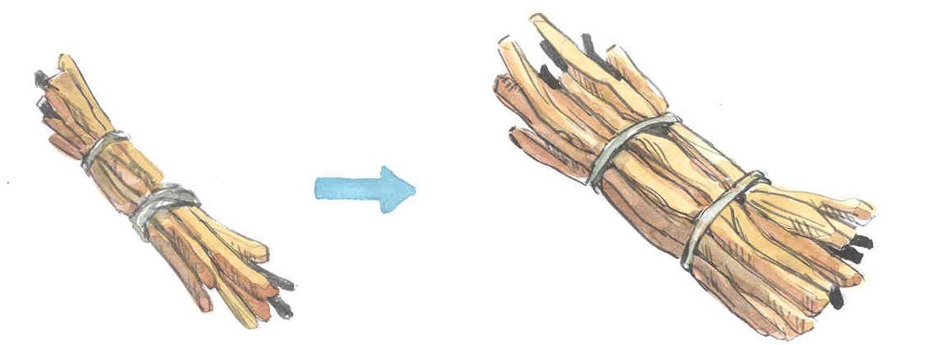

Resources that are increasing

The management response could be:

- To continue current harvesting levels.
- To increase harvesting of the specific resource. It is important that increases are small in order to prevent over harvesting.
- To increase the number of licenses issued for the specific resource. It is important that increases are small in order to prevent over harvesting.
- To decrease the price of the license for the specific resource in order to make it more favourable to extract.

Important notice: If a selected management response does not work well, the Village Natural Resource Committee should discuss and agree on another way of responding to the problem encountered.



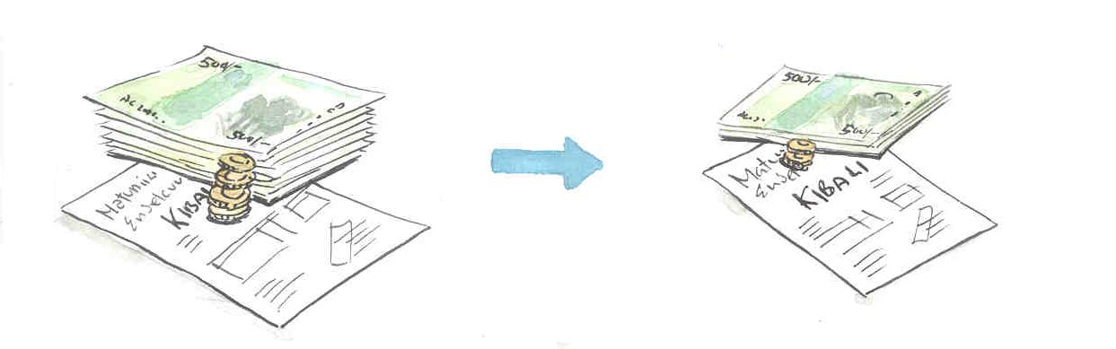

- Village Natural Resource Committee activities and decisions that should be presented at Village General Assemblies

Who is responsible for informing villagers about Village Natural Resource Committee activities and decisions?
- The Village Natural Resource Committee Chairman is responsible for making sure that the Monthly report from the Village Natural Resource Committee reaches the villagers (e.g. on a notice board).
- The Village Natural Resource Committee Chairman is also responsible for making reports from the Forest Co-ordination Committee and District authorities available to villagers (e.g. on a notice board).
- The Village Chairman should organise quarterly Village General Assemblies where the activities of the Village Natural Resource Committee are presented by the Village Natural Resource Committee Chairman.

How often should Village Natural Resource Committee activities be presented at Village General Assemblies?
- Village General Assemblies should be held quarterly to report on Village Natural Resource Committee activities.

Information to be presented and discussed at Village General Assemblies

The following issues should be raised and discussed:

Revenue and expenditure of the Village Natural Resource Committee.
- The Village Natural Resource Committee manages the forest on behalf of the villagers. The committee should therefore present revenue and expenditure related to natural resource use.

Illegal activities observed in the forest.
- Illegal resource extraction should be presented and villagers should be made aware of current rules and regulations.

Suggested changes to rules and regulations in the Management Plan, which are:
- Intended to stop illegal activities in the forest.
- Intended to stop further decrease of a resource.
- Intended to increase the availability of a resource.

NB. During Village General Assemblies, it is important that Village Natural Resource Committee members listen to the villagers’ perceptions of resource status and trends. It is also important to consider their recommendations for actions and integrate these into Village Natural Resource Committee decisions.

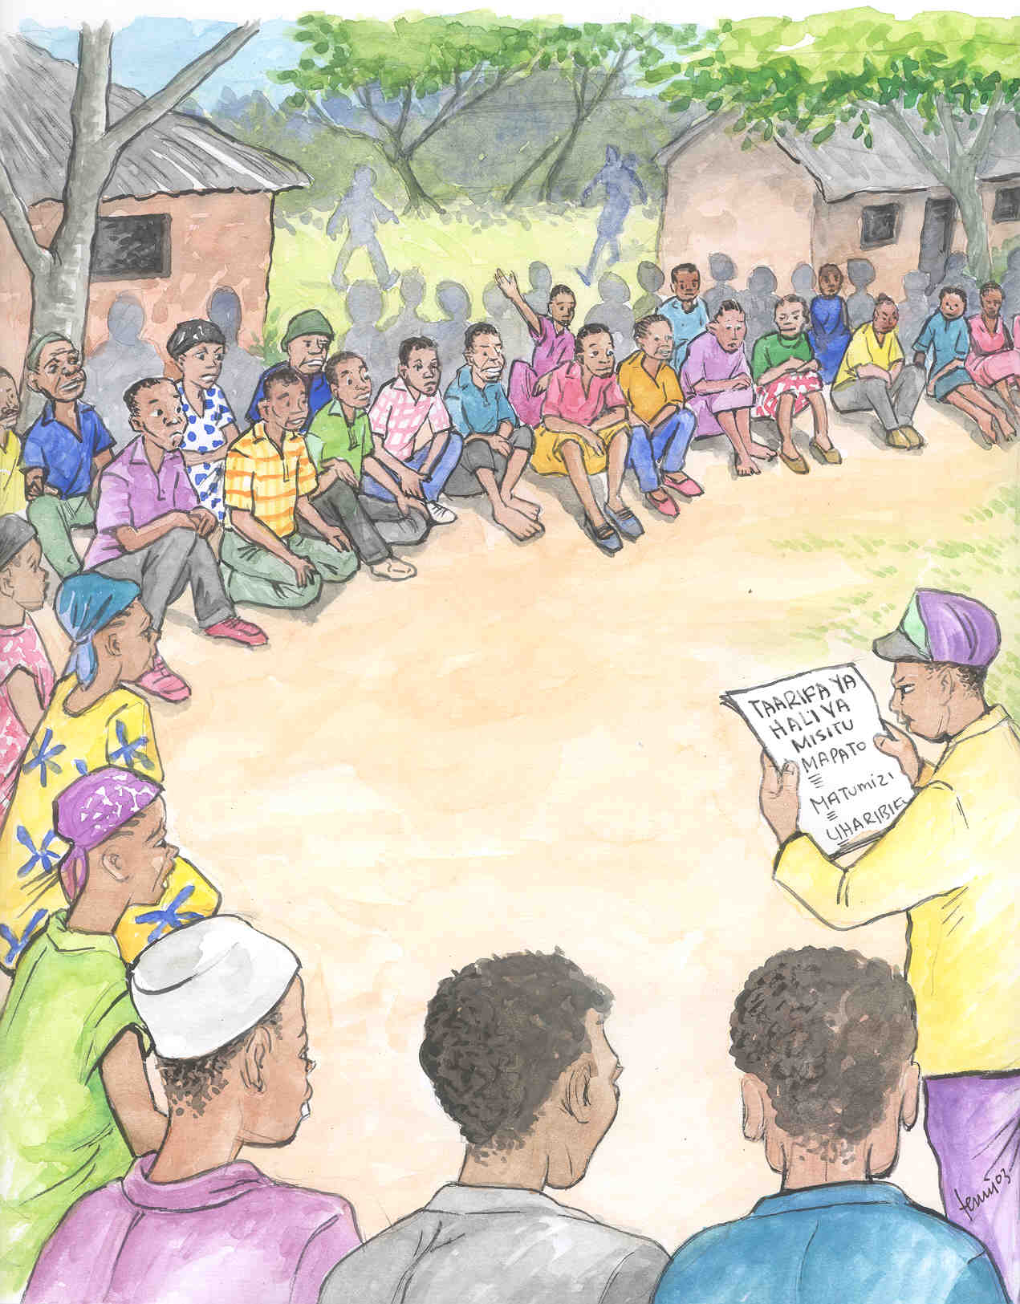
Annex 1. Patrol Form

Patrol form for Village Natural Resource Committee (NWMP)

Village |  |  |  | Date
Area/ Path |  |  |  | Start time
Names of Patrol Guards |  |  |  | End time
1.
2. |  |  |  | Time used for breaks
3.
4. |  |  |  | Total time spend on patrol

Resource extraction/ Disturbance/ Threat
Record only these listed activities, which pose a threat to the forest: Cut trees, Cut poles, Fire, Charcoal burning, Agricultural encroachment, Livestock grazing, Traps, Natural honey collection (if tree has died).
Time | What have you seen (Resource extraction/ disturbance/ Threat) | Number of  trees/ traps, or  Size of area  (Fire or agriculture) | Comments to observations  (e.g. How old, Tree species, Reason for disturbance, etc)

Wildlife observations/ forest health (biodiversity) indicators
Record only these listed animals which are vulnerable to forest disturbance:
Bush Pig, Warthog, Kirk’s Dikdik, Oribi, Impala, Greater Kudu, Buffalo, Elephant, Guineafowl, Red-necked Spurfowl
Time | Species | Animal seen Animal heard Droppings seen | No of animals/ droppings | Remarks: How old is the dung, or is it the first time the animal is observed in this patrol area? Others.
Additional comments from Patrol Guards regarding the status of the forest and its resources:

Patrol form for Village Natural Resource Committee (UMFM)

Village |  |  |  | Date
Area/ Path |  |  |  | Start time
Names of Patrol Guards |  |  |  | End time
1.
2. |  |  |  | Time used for breaks
3.
4. |  |  |  | Total time spend on patrol

Resource extraction/ Disturbance/ Threat
Record only these listed activities, which pose a threat to the forest: Traps, Cut trees, Fire, Agricultural encroachment, Livestock grazing, Charcoal burning, Bark harvesting (if more than half the circumference of the tree), Natural honey collection (if tree has died).
Time | What have you seen (Resource extraction/ disturbance/ Threat) | Number of  trees/ traps, or  Size of area  (Fire or agriculture) | Comments to observations  (e.g. How old, Tree species, Reason for disturbance, etc)

Wildlife observations/ forest health (biodiversity) indicators
Record only these listed animals which are vulnerable to forest disturbance:.
Udzungwa Red Colobus, Angolan Black and White Colobus, Sanje Mangabey, Abbott’s Duiker, Harvey’s Red Duiker, Suni, Buffalo, Bush Pig, Hyrax, Livingstone’s Turaco, Hornbills (Silvery-cheeked Hornbill, Trumpeter Hornbill)
Time | Species | Animal seen Animal heard Droppings seen | No of animals/ droppings | Remarks: How old is the dung, or is it the first time the animal is observed in this patrol area? Others.
Additional comments from Patrol Guards regarding the status of the forest and its resources:

Annex 2. Perception Interview Form
Interview Form for Village Natural Resource Committee (NWMP)
Villagers perception of status and trend of natural resources
Village: |  |  |  |  |  |  |  |  | Occupation of villagers: |  |  |  |  |  |  | Agriculture
Subvillage |  |  |  |  |  |  |  |  | (Tick the appropriate boxes) |  |  |  |  |  |  | Pastoralist
Date |  |  |  |  |  |  |  |  |  |  |  |  |  |  |  | Fisherman
Name of Interview Chairman and  the VNRC member |  |  |  |  |  |  |  |  |  |  |  |  |  |  |  | Natural resource business
 |  |  |  |  |  |  |  |  |  |  |  |  |  |  |  | Others:_____________________
1. |  |  |  |  |  |  |  |  |  |  |  |  |  |  |  | (Write if others)
2. |  |  |  |  |  |  |  |  |  |  | No of females: |  |  |  |  | No of males:
What is the villagers perception of status and trend of some of the important natural resources coming from the natural forest?
Natural resource |  |  | Status of resource  -Abundant  -Sufficient  -Scarce |  |  |  | Trend of resource  -Increasing  -Stable  -Decreasing |  |  |  |  | Main reason for trend
Firewood
Charcoal
Timber
Building materials
Medicinal plants
Grass for thatching
Others:
Others:
Which resources from the natural forest is most important to your family? |  |  |  |  |  | Where can these resource be found today compared to 10 years ago?  (Underline answer)
1. |  |  |  |  |  | Nearer the household / No change / Further away from the household
2. |  |  |  |  |  | Nearer the household / No change / Further away from the household
3. |  |  |  |  |  | Nearer the household / No change / Further away from the household
Information regarding wildlife found near the village
Which animals are considered a problem to your crops or livestock? |  |  |  |  | What is the status of these animals?  (Underline answer) |  |  |  |  |  |  |  |  |  | What is the trend of these animals?  (Underline answer)
1. |  |  |  |  | Abundant / Sufficient / Scarce |  |  |  |  |  |  |  |  |  | Increasing / Stable / Decreasing
2. |  |  |  |  | Abundant / Sufficient / Scarce |  |  |  |  |  |  |  |  |  | Increasing / Stable / Decreasing
3. |  |  |  |  | Abundant / Sufficient / Scarce |  |  |  |  |  |  |  |  |  | Increasing / Stable / Decreasing
4. |  |  |  |  | Abundant / Sufficient / Scarce |  |  |  |  |  |  |  |  |  | Increasing / Stable / Decreasing
5. |  |  |  |  | Abundant / Sufficient / Scarce |  |  |  |  |  |  |  |  |  | Increasing / Stable / Decreasing
Information regarding villager’s knowledge of VNRC activities
Ask the villager to mention some VNRC activities that are known to the villagers |  |  |  |  | 1.
 |  |  |  |  | 2.
 |  |  |  |  | 3.

Interview Form for Village Natural Resource Committee (UMFM)
Villagers perception of status and trend of natural resources
Village: |  |  |  |  |  |  |  |  | Occupation of villagers: |  |  |  |  |  |  | Agriculture
Subvillage |  |  |  |  |  |  |  |  | (Tick the appropriate boxes) |  |  |  |  |  |  | Pastoralist
Date |  |  |  |  |  |  |  |  |  |  |  |  |  |  |  | Fisherman
Name of Interview Chairman and  the VNRC member |  |  |  |  |  |  |  |  |  |  |  |  |  |  |  | Natural resource business
 |  |  |  |  |  |  |  |  |  |  |  |  |  |  |  | Others:_____________________
1. |  |  |  |  |  |  |  |  |  |  |  |  |  |  |  | (Write if others)
2. |  |  |  |  |  |  |  |  |  |  | No of females: |  |  |  |  | No of males:
What is the villagers perception of status and trend of some of the important natural resources coming from the natural forest?
Natural resource |  |  | Status of resource  -Abundant  -Sufficient  -Scarce |  |  |  | Trend of resource  -Increasing  -Stable  -Decreasing |  |  |  |  | Main reason for trend
Medicinal plants
Honey
Wild vegetables
Others:
Others:
Others:
Others:
Others:
Which resources from the natural forest is most important to your family? |  |  |  |  |  | Where can these resource be found today compared to 10 years ago?  (Underline answer)
1. |  |  |  |  |  | Nearer the household / No change / Further away from the household
2. |  |  |  |  |  | Nearer the household / No change / Further away from the household
3. |  |  |  |  |  | Nearer the household / No change / Further away from the household
Information regarding wildlife found near the village
Which animals are considered a problem to your crops or livestock? |  |  |  |  | What is the status of these animals?  (Underline answer) |  |  |  |  |  |  |  |  |  | What is the trend of these animals?  (Underline answer)
1. |  |  |  |  | Abundant / Sufficient / Scarce |  |  |  |  |  |  |  |  |  | Increasing / Stable / Decreasing
2. |  |  |  |  | Abundant / Sufficient / Scarce |  |  |  |  |  |  |  |  |  | Increasing / Stable / Decreasing
3. |  |  |  |  | Abundant / Sufficient / Scarce |  |  |  |  |  |  |  |  |  | Increasing / Stable / Decreasing
4. |  |  |  |  | Abundant / Sufficient / Scarce |  |  |  |  |  |  |  |  |  | Increasing / Stable / Decreasing
5. |  |  |  |  | Abundant / Sufficient / Scarce |  |  |  |  |  |  |  |  |  | Increasing / Stable / Decreasing
Information regarding villager’s knowledge of VNRC activities
Ask the villager to mention some VNRC activities that are known to the villagers |  |  |  |  | 1.
 |  |  |  |  | 2.
 |  |  |  |  | 3.

Annex 3. Report from Village Natural Resource Committee
To: District Lands, Natural Resources and Environment Office
Copy to: Ward Executive Officer
Divisional Secretary
 | Report from Village Natural Resource Committee |  |  |  |  | Village: |  |  |  |  |  |  |  |  |  |  |  |  | Month and year:
 | Names and positions of committee members  Positions:  Chairman, Secretary, Treasurer, Patrol Commander, Interview Chairman, others. |  |  |  |  | Females |  |  |  |  |  |  |  |  |  |  |  |  | Males
 |  |  |  |  |  | 1. |  |  |  |  |  |  |  |  |  |  |  |  | 1.
 |  |  |  |  |  | 2. |  |  |  |  |  |  |  |  |  |  |  |  | 2.
 |  |  |  |  |  | 3. |  |  |  |  |  |  |  |  |  |  |  |  | 3.
 |  |  |  |  |  | 4. |  |  |  |  |  |  |  |  |  |  |  |  | 4.
 |  |  |  |  |  | 5. |  |  |  |  |  |  |  |  |  |  |  |  | 5.
 |  |  |  |  |  | 6. |  |  |  |  |  |  |  |  |  |  |  |  | 6.
 |  |  |  |  |  | 7. |  |  |  |  |  |  |  |  |  |  |  |  | 7.
 | Meetings/  Training |  | Date |  |  |  |  | No of attendants  (Females) |  |  |  | No of attendants  (Males) |  |  |  |  | Issues related to natural resources
 | Village Natural Resource Committee meetings
 | Village General Assemblies
 | Training/ Workshops
 | No of Permits, Revenue from resource/services, revenue from fines and Expenditure
 | Natural resource /  Service from forest |  |  |  | No of permits |  |  |  |  |  |  |  | Revenue Tshs. |  |  |  |  |  |  | Fines
 |  |  |  |  |  |  |  |  |  |  |  |  |  |  |  |  |  |  |  | Number of fines
 |  |  |  |  |  |  |  |  |  |  |  |  |  |  |  |  |  |  |  | Revenue from fines (Tshs)
 |  |  |  |  |  |  |  |  |  |  |  |  |  |  |  |  |  |  |  | Expenditure (Tshs)
 |  |  |  |  |  |  |  |  |  |  |  |  |  |  |  |  |  |  |  | Natural resources expenditure (Tshs)
 | Total number of permits and revenue from forest resources/services |  |  |  | Total number of permits |  |  |  |  |  |  |  | Total revenue from resources/services |  |  |  |  |  |  | Village expenditure (Tshs)
 |  |  |  |  |  |  |  |  |  |  |  |  |  |  |  |  |  |  |  | Total expenditure (Tshs)
 | Remarks:
 | Date: |  |  |  |  |  | Date: |  |  |  |  |  |  |  |  |  |  |  |  |  | Date:
 | …..…….………………………  Signature  VNRC Secretary |  |  |  |  |  | ……………………………….  Signature  VNRC Chairman |  |  |  |  |  |  |  |  |  |  |  |  |  | ……………………………………  Signature  Village Chairman
Monthly patrol report |  |  |  |  |  |  |  |  | No. 1 |  |  | No. 2 |  |  |  | No. 3 |  |  |  |  |  | No. 4 |  |  |  | No. 5 |  |  | No. 6
Date
Time spend on patrol
Resources/ disturbances/ threats  (Transfer from VNRC Patrol Form) |  |  |  | Number of forms where the specific resource extraction/ disturbance was observed |  |  |  |  |  |  |  |  |  | Write the total:  number of trees,  number of traps or  Size of area |  |  |  |  |  |  |  |  | Main cause
Animals  (Transfer from VNRC Patrol Form) |  |  |  | Number of forms where the each species has been observed |  |  |  |  |  |  |  |  |  | Total number of individuals seen or heard by the Patrol Guards |  |  |  |  |  |  |  |  |  |  | Total number of dungpiles found for each species
Monthly interview summary, regarding status and trend of important natural resources
Interviews  At least:5 |  | Total number of forms |  | Number of females |  |  |  |  |  | Number of males |  |  |  |  | Occupation of interviewed persons
Resources from the forest  (Transfer from Interview Form) |  |  |  | For every resource, on how many forms have they written:
 |  |  |  | Status of resource Abundant |  |  |  |  |  |  | Status of resource  Sufficient |  |  |  |  |  |  | Status of resource  Scarce |  |  |  |  |  | Trend: Increasing |  |  | Trend: Decreasing
Regarding resources (and animals) that are decreasing
What do the Natural Resource Committee think is the cause of the decrease?
VNRC comments on forest health and trend in resource use, including comments to present rules regarding permits and fees.

